1. Test cases for class DeliveryInfo
1.1 Method boolean checkAddessSupportability()
TC | Name | Phone | Email | Address | Province | Expected
1 | Duong Hoang Hai | 0123456789 | abc@gmail.com | Thanh Xuan | Hanoi | true
2 | John Doe | 0987654321 | jdoe@example.com | Wall Street | New York | false

1.2 Method boolean validateDeliveryInfo()
TC | Name | Phone | Email | Address | Province | Expected
1 | Duong Hoang Hai | 0123456789 | abc@gmail.com | Thanh Xuan | Hanoi | true
2 | Alice Johnson | 1234567890 | ab c@example.com | Central | Sydney | false
3 | Bob Brown | 12345678 | brown@example.com | Downtown | Chicago | false
4 | Carol White | 09876543210 | white@example.com | Midtown | Atlanta | false
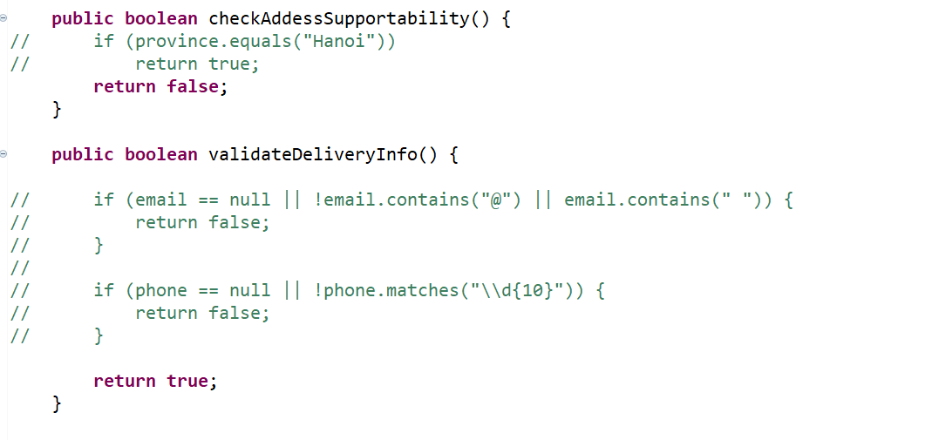
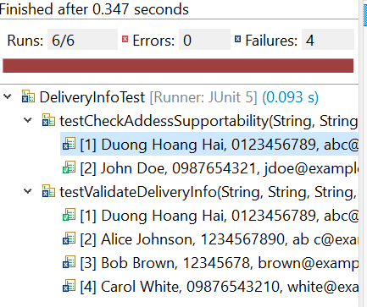
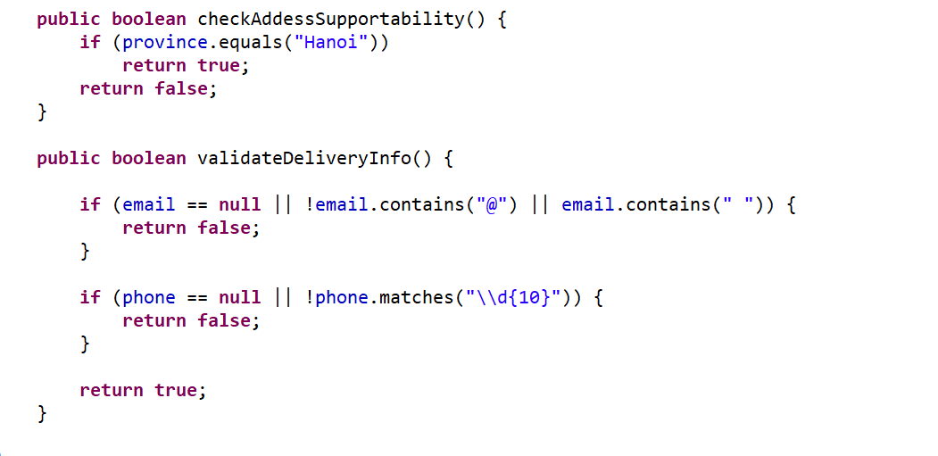
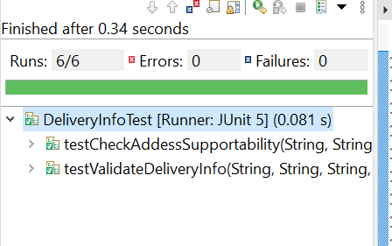

2. Test cases for class Cart
Method boolean checkProductAvailability()
TC1 :
title | quantityInStock | price | weight | rushOrderEligible | quantityInCart
Jungle | 20 | 10000 | 1.2 | true | 21
Tom Cat | 10 | 20000 | 1.3 | true | 5

Expected : false
TC2 :
title | quantityInStock | price | weight | rushOrderEligible | quantityInCart
Jungle | 20 | 10000 | 1.2 | true | 10
Tom Cat | 10 | 20000 | 1.3 | true | 11

Expected : false
TC3 :
title | quantityInStock | price | weight | rushOrderEligible | quantityInCart
Jungle | 20 | 10000 | 1.2 | true | 21
Tom Cat | 10 | 20000 | 1.3 | true | 5
Adventure | 5 | 15000 | 2.1 | false | 3

Expected : true
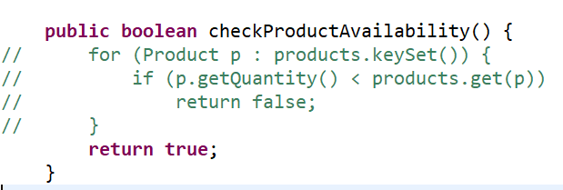

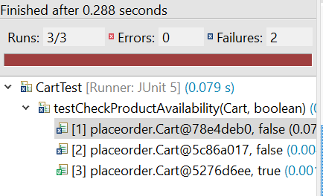

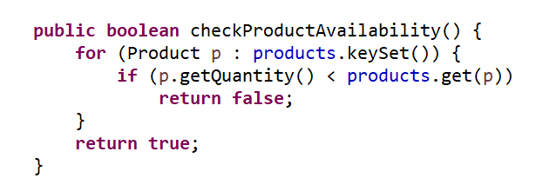
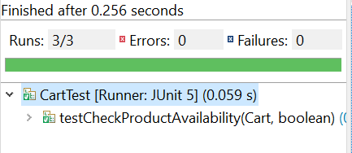
3. Test cases for class PlaceOrderController
Cart 1 :
title | quantityInStock | price | weight | rushOrderEligible | quantityInCart
Jungle | 20 | 10000 | 1.2 | true | 3
Tom Cat | 10 | 15000 | 1.5 | true | 2

Cart 2 :
title | quantityInStock | price | weight | rushOrderEligible | quantityInCart
Jungle | 20 | 10000 | 1.2 | true | 1
Tom Cat | 10 | 15000 | 1.5 | true | 1

Cart 3 :
title | quantityInStock | price | weight | rushOrderEligible | quantityInCart
Jungle | 20 | 10000 | 1.2 | true | 5
Tom Cat | 10 | 15000 | 1.5 | true | 1

TC | Cart | Province | Expected
1 | Cart 1 | Hanoi | 27000
2 | Cart 1 | Da Nang | 47500
3 | Cart 2 | Ho Chi Minh City | 22000
4 | Cart 2 | Hai Phong | 35000
5 | Cart 3 | Hanoi | 37000
6 | Cart 3 | Da Nang | 57500

